[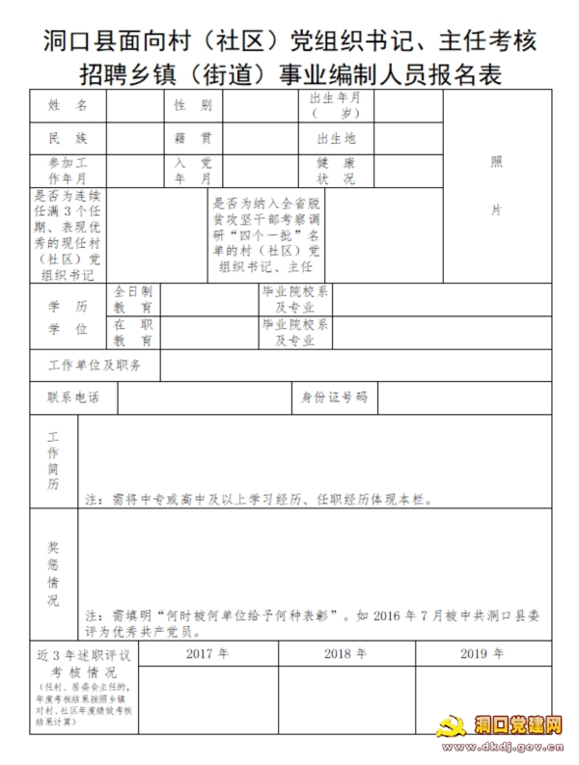](http://www.dkdj.gov.cn/UploadFiles/Class78/2020/10/202010191934420911.jpg)[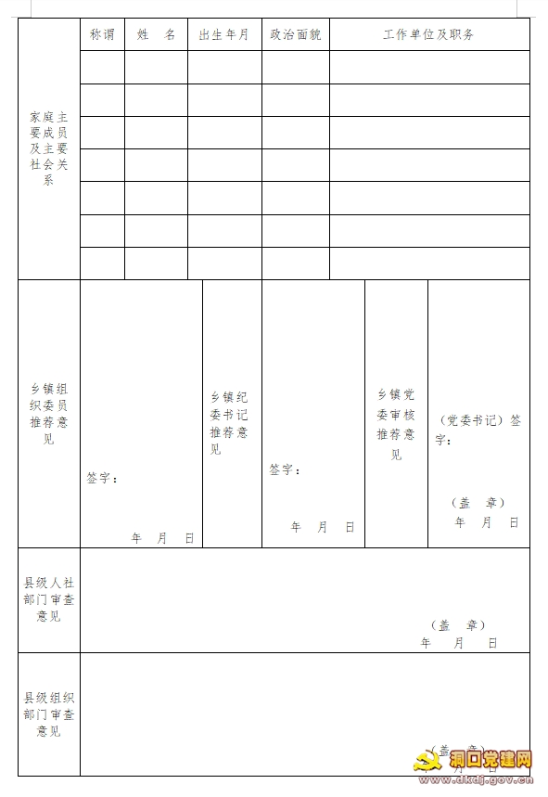](http://www.dkdj.gov.cn/UploadFiles/Class78/2020/10/202010191934456892.png)[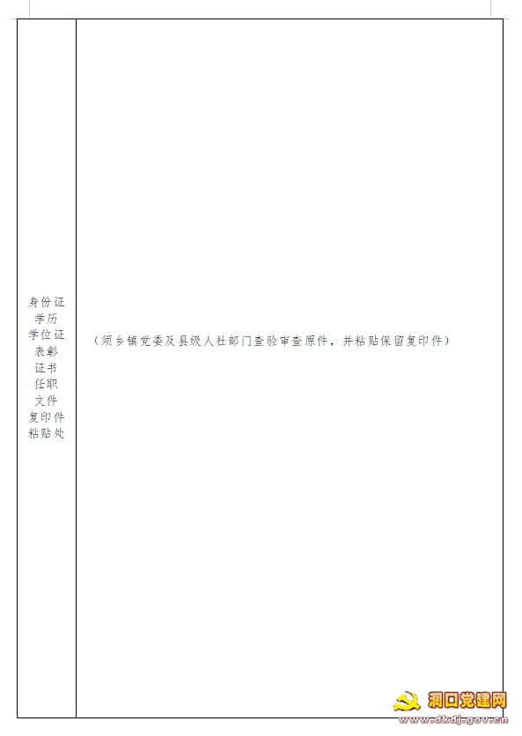](http://www.dkdj.gov.cn/UploadFiles/Class78/2020/10/202010191934459659.png)